Weather Observation Station 20

A [*median*](https://en.wikipedia.org/wiki/Median) is defined as a number separating the higher half of a data set from the lower half. Query the median of the Northern Latitudes (LAT_N) from **STATION** and round your answer to  decimal places.

**Input Format**

The **STATION** table is described as follows:

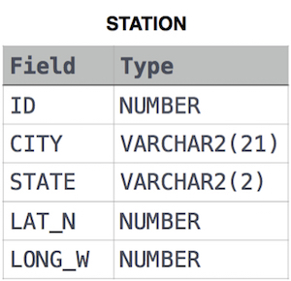

where LAT_N is the northern latitude and LONG_W is the western longitude.

SELECT ROUND(LAT_N, 4)

FROM (

SELECT ROW_NUMBER() OVER (ORDER BY LAT_N ASC) AS ID, LAT_N

FROM STATION

) AS h

WHERE ID IN (

SELECT CEIL(COUNT(*) / 2)

FROM STATION

)